Prompts
- Document Segmentation
You are an ontology engineering assistant. Read the following EU AI Act file and extract structured information. Each item must include:
concept (short, descriptive name), description (concise explanation of the concept), category (AI system category / Actor / Obligation / Governance), article_reference (original Act article number)
Ensure output is complete, non-redundant, and highlight any ambiguous concepts.

- Concept Extraction
“You are building an ontology for the EU AI Act. Based on the structured concepts, generate a hierarchical class structure under the following upper-level classes: Thing → {AI_System, Actor, Obligation, Governance}, AI_System → {Prohibited_AI_Practice, High_Risk_AI_System, Certain_AI_System, General_Purpose_AI_Model }, Actor → {Provider, Deployer, Distributor, Importer, Authority}. And proposed new subclasses for Obligation and Governance where appropriate.
Ensure subclasses are semantically consistent with the concept description.
Avoid duplicate or ambiguous class names.
Return results in a class hierarchy format.

- Ontology Schema Design
For the generated ontology classes, propose object properties representing their relationships. For each property, provide:
property name (concise, descriptive)
domain (source class)
range (target class)
description (semantic meaning, purpose)
optional: inverse property
Suggest reuse of standard ontologies if applicable but preserve original class hierarchy.

- OWL Ontology Generation
Generate an OWL ontology in Turtle syntax based on the class hierarchy, object properties, and annotations. Preserve class hierarchy and naming.
Before generating the OWL ontology, explain your reasoning for each class and property assignment, including why the domain, range, and subclass hierarchy are appropriate.

- Instances generation
Generate example individuals for the ontology classes, ensuring that:
each instance corresponds to a defined class.
relationships between instances are valid according to the ontology.
at least one instance per major class is provided.
include source article reference or description for verification.

- ROBOT template generation
Convert the ontology (Turtle format) into a ROBOT template, ensuring:
every class, property, and individual are represented.
semantic hierarchy and relationships are preserved.
missing definitions are inferred from concept names and source text.
naming conventions are consistent.
output strictly conforms to ROBOT template format.

Competency questions and SPARQL queries
CQ1: Which actors must report to market surveillance authorities?
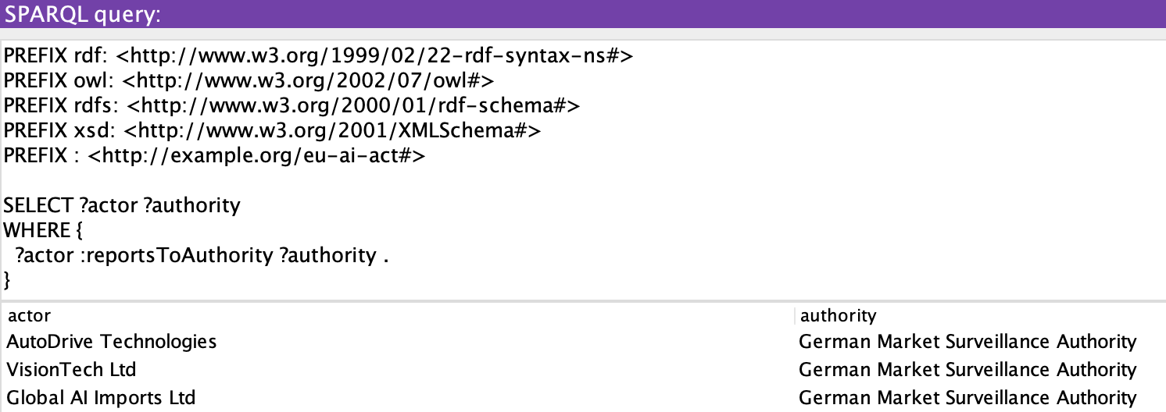
CQ2: Which providers develop High-Risk AI systems and what obligations must they comply with?
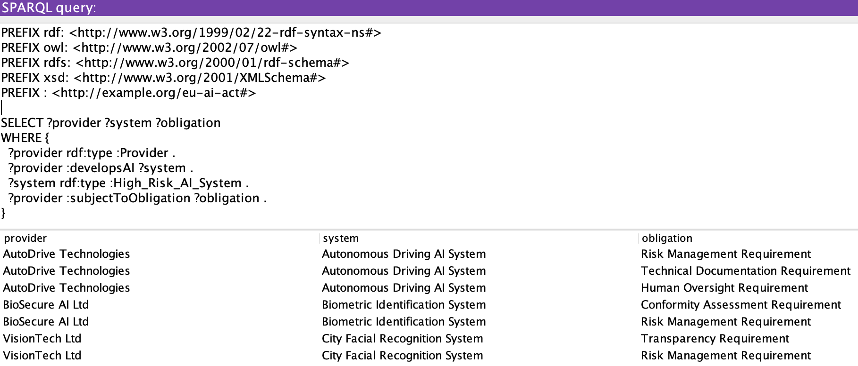
CQ3: What obligations apply to High-Risk AI Systems?
